D840R-How to update software？
Product line: ADSL Question category: Function configurations

Q: Why we need to upgrade firmware for the router?
A: Sometimes we may need to upgrade the router to another firmware version if the current firmware version can no longer satisfy your requirement. For example, the new firmware will be able to fix some bugs and to achieve better service.

Warning:
1. Upgrade with Ethernet cable.
2. Do not power off the router when upgrading
3. Do not upgrade remotely, please connect your PC and router directly to perform the upgrade.
4. Please make sure the firmware is correct.
5. We suggest you use Internet Explorer to upgrade.

I. Physical connection:
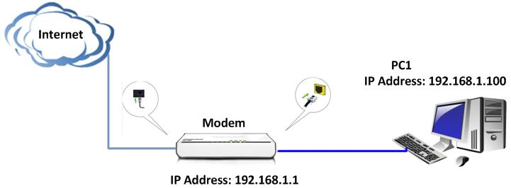
II. Login to the management page of the router:

1. Open a web browser (IE, Firefox, Safari, etc.) and find the address bar, leaving it blank before typing in 192.168.1.1, and then press enter.
(Care: The address bar is in the most top of the web page after opening web browser).
2. Input default username and password:admin in the following window, then click ok.
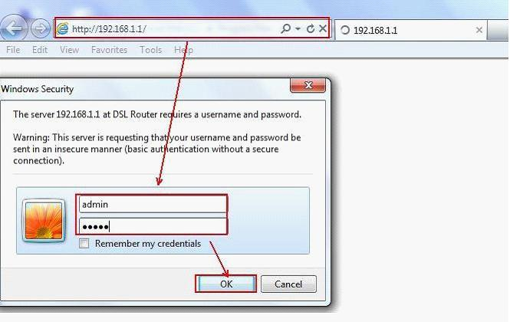
3. On the left side, please click on System tool and then click on update software. Please click on Browse to add the new software and then click on Update software to achieve that. 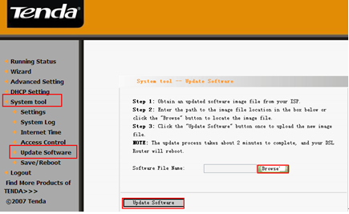

4. After rebooting, please go back to 192.168.1.1 and click on Advanced Settings in the initial page, then go to Management->Restore Default on the left menu to restore the router to factory default. After restoring, you should set up the router again.

